***A.A.GOVERNMENT ARTS COLLEGE,MUSIRI***

***Affiliated To Bharathidhasan University ,Tiruchirappalli***

***NAANMUTHALVAN PROJECT-||| BSC MATHEMATICS***

***TOPIC:***

***POLITICAL JUGGERNAUTS:A QUANTITATIVE ANALYSIS OF***

***CANDIDATES IN THE 2019 LOK SABHA ELECTIONS***

***Submitted By***

***TEAM LEADER: M.BOOMIKA(DC7824FCC01A0C2BA0A4043BEE42D9C1)***

***MEMBERS:***

***S.RENUKA (7718381807E2ABEBD75438115DD5A533)***

***M.HARINI(55BA16C84E0E403BA0441C54BA914D0F)***

***P.SUBASRI(08CF2C4694F7FFC98FB4FE3762B3AA7A)***

***Indroduction:***

***Lok sabha is the house of representatives directly elected by the people.hence,the lok sabha is called the first house’ .***

***The members a lok sabha are elected directly by people from the Terriotorial constituencies’.***

***The tenure of lok sabha is five years.***

***The first session of this lok sabha commented on 13 may 1952***

***.General elections we held in India is seven phases from 11 April to 19 may 2019 to elect the members of the 17th lok sabha votes were counted and the result was declared on 23 may .***

***The election resulted in a landslide victory For the BJP which won 303 seats and formed the government .***

***The Lok sabha comprises of a total of 545 seats.***

***The Lok sabha or the Lower house has 543 members.***

***The prime minister is the leader of the lok sabha.***

Empathy Map

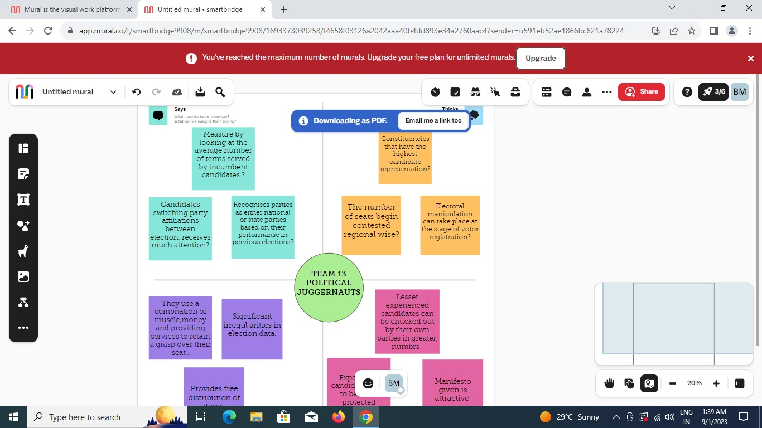

Brainstorming Map

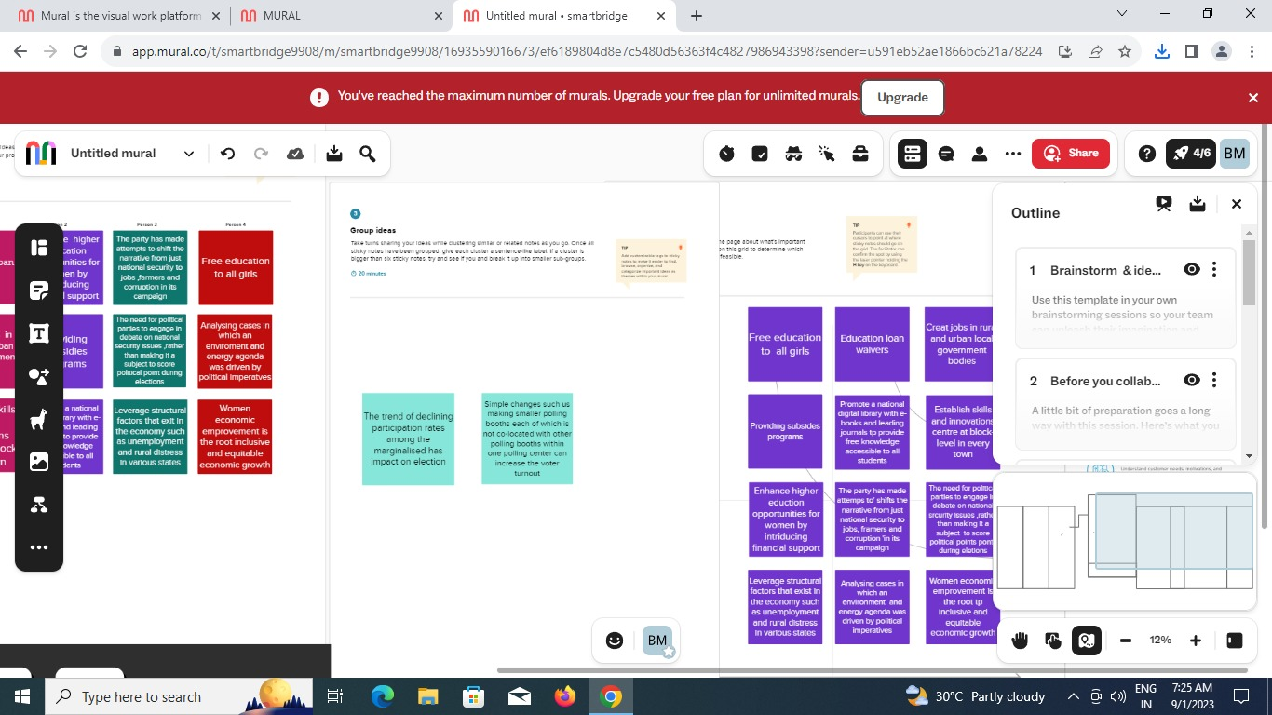

DATASET

Data visualization

Sheet:1

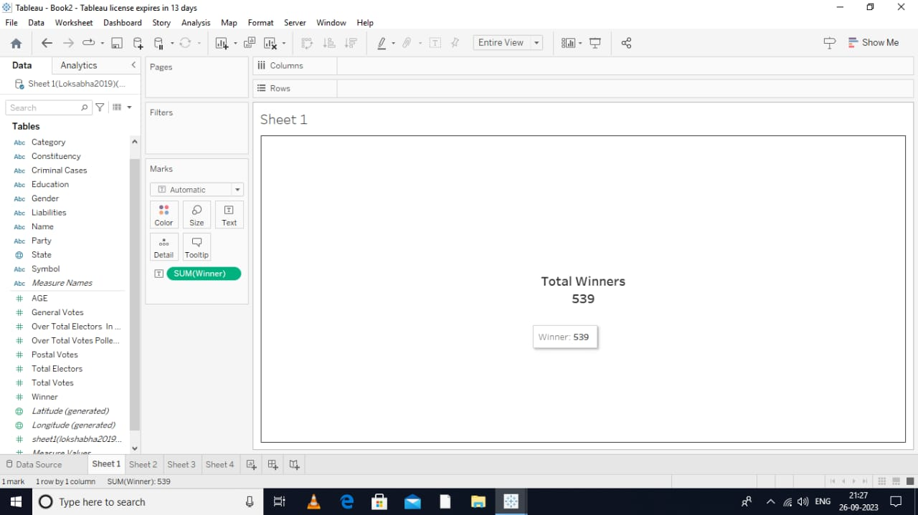

Sheet :2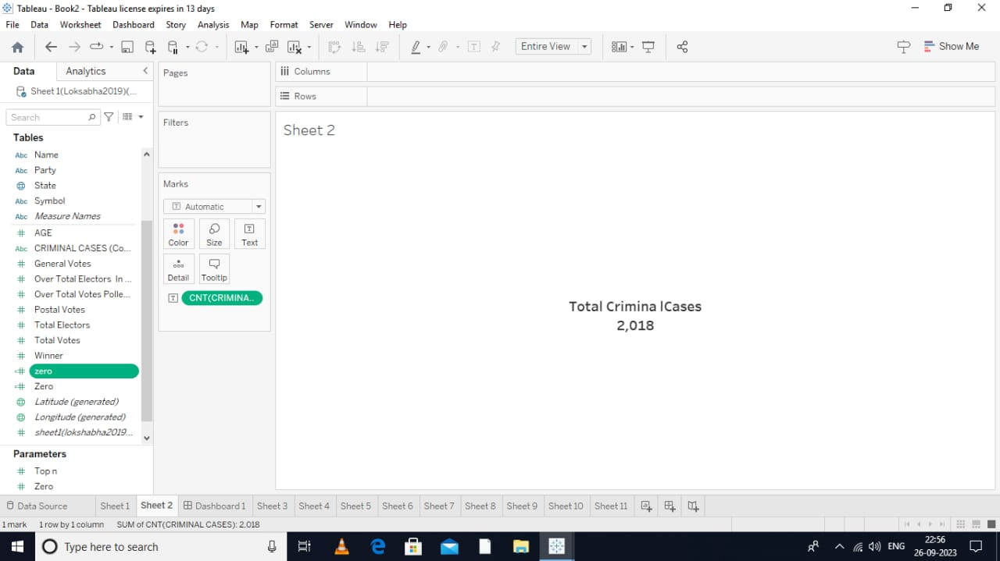

Sheet:3

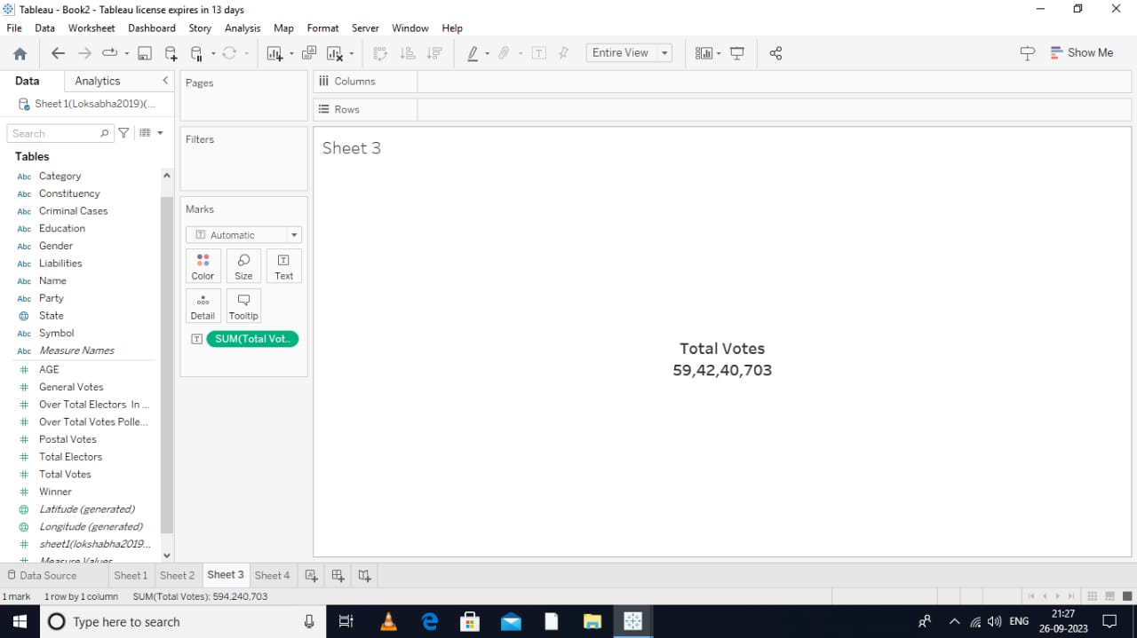

Sheet:4

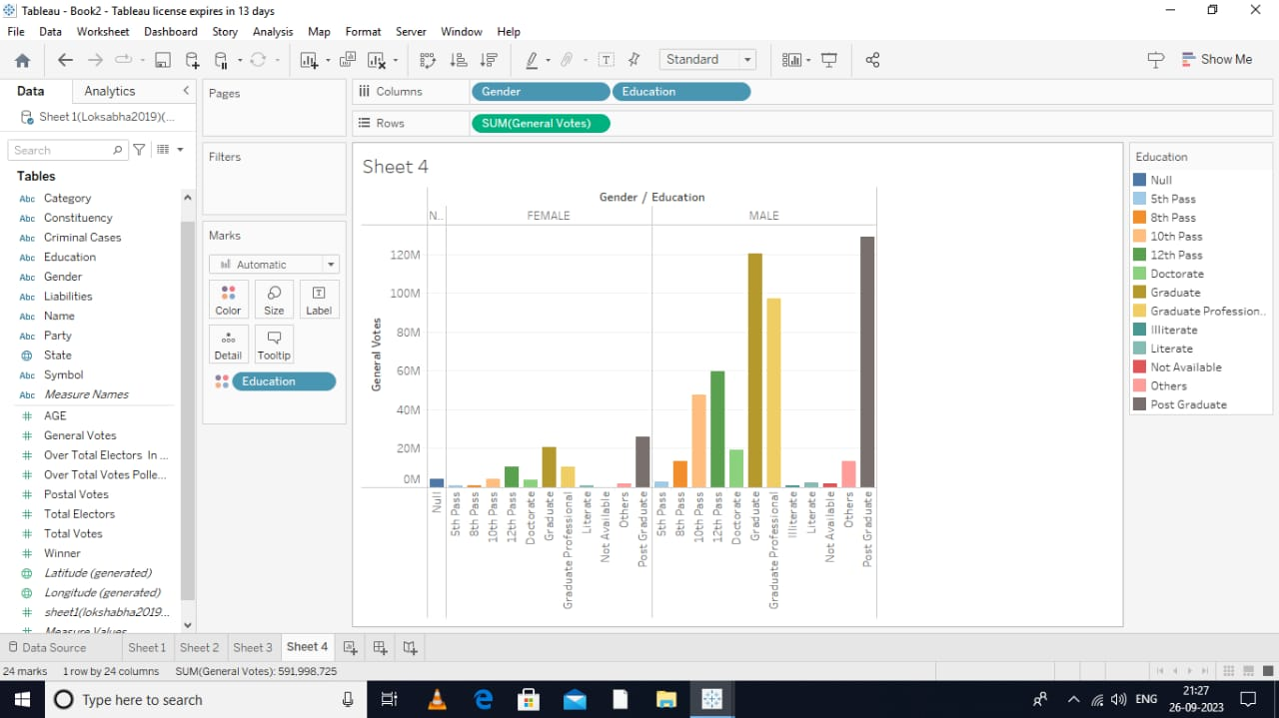

Sheet:5

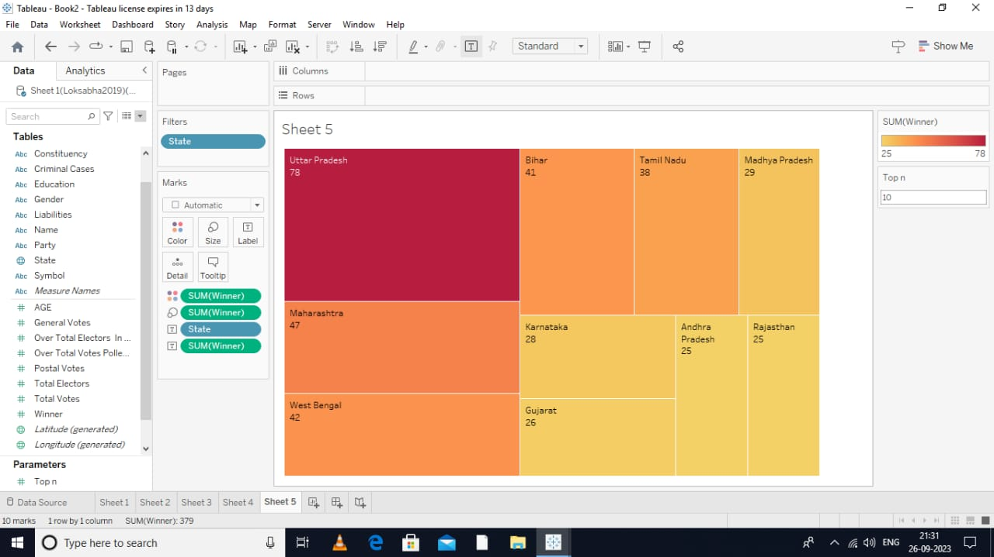

Sheet:6

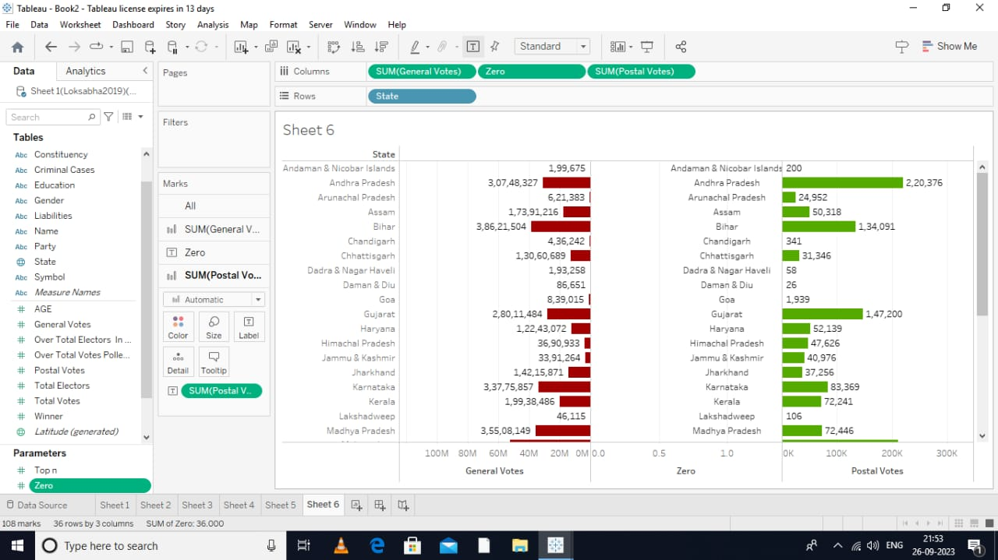

Sheet:7

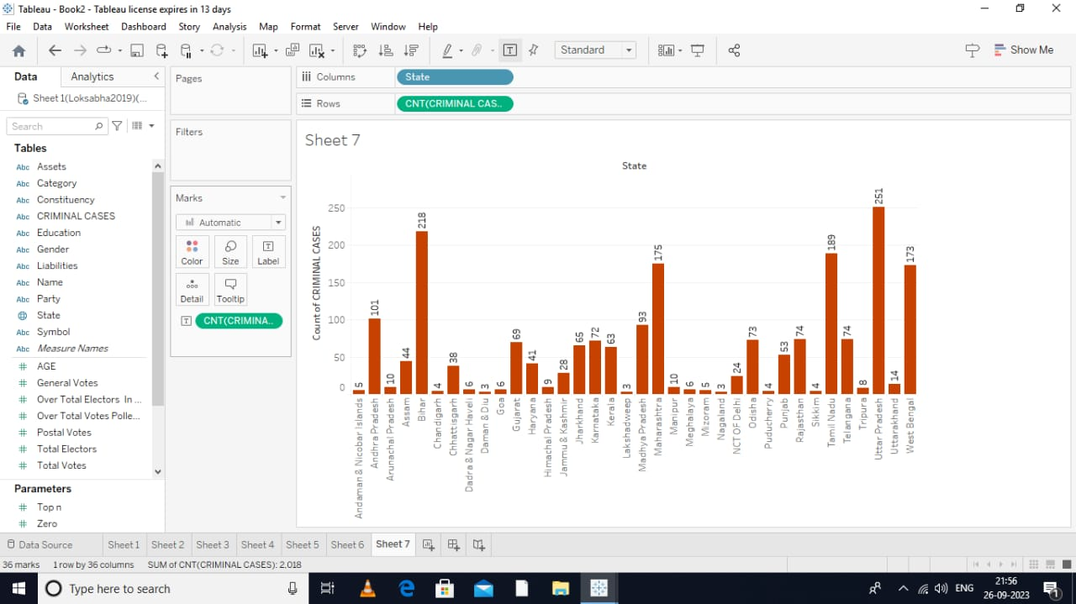

Sheet:8

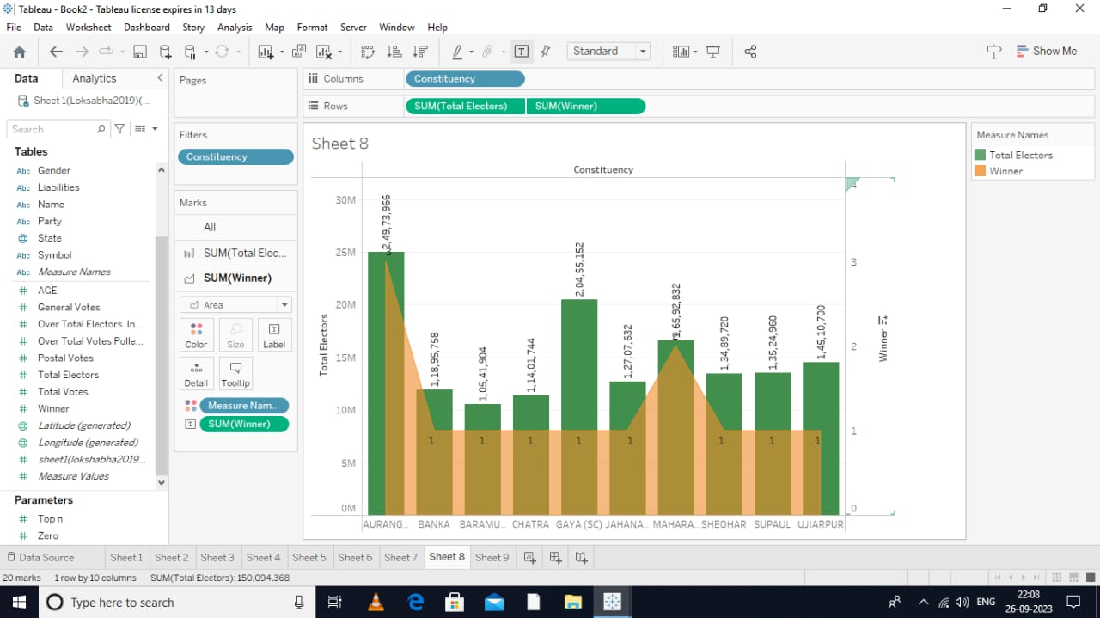

Sheet:9

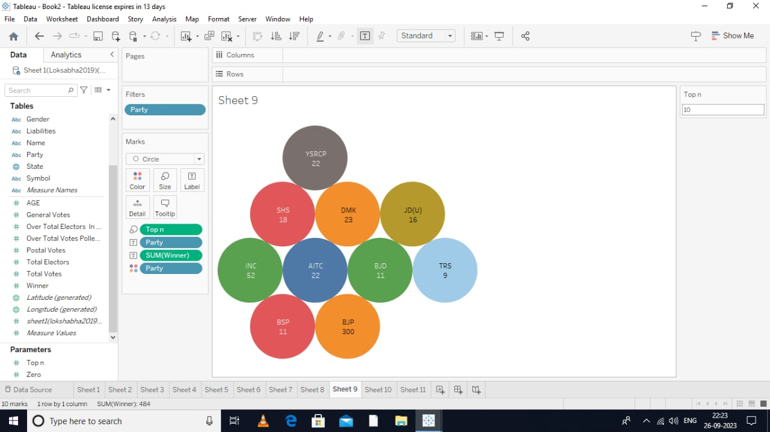

Sheet:10

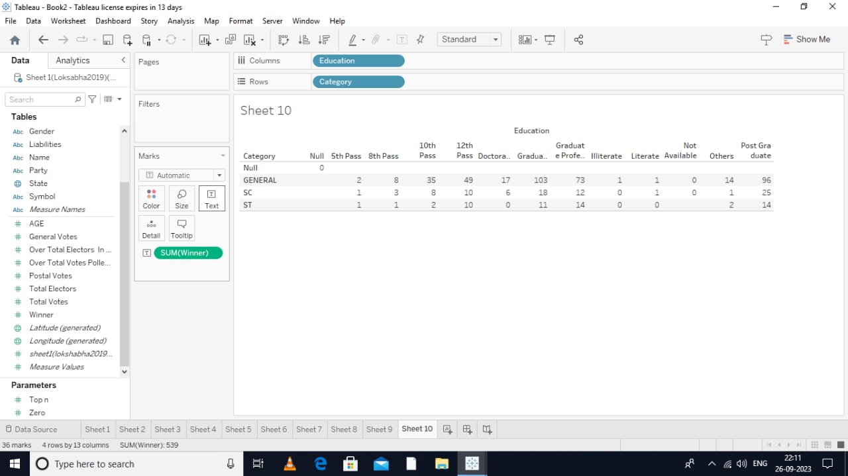

Sheet:11

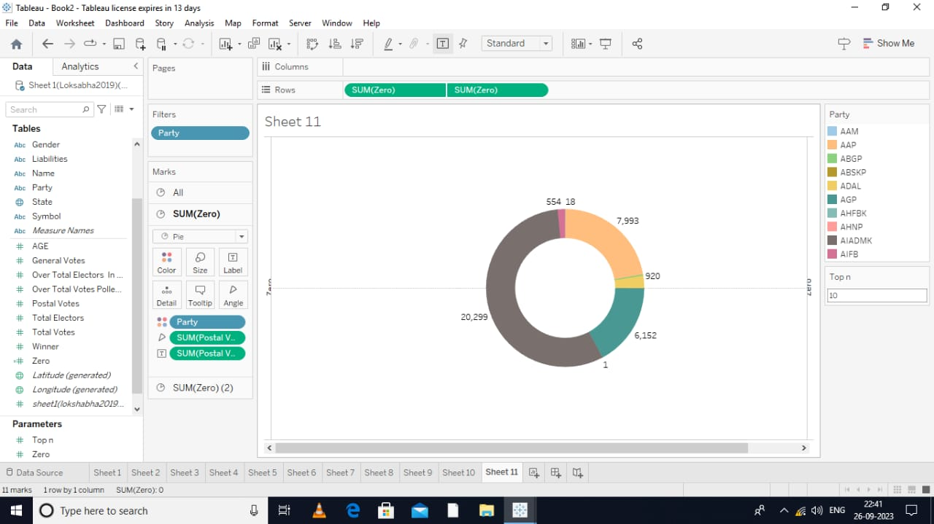

Dashbord

Sheet:1

* 

Sheet:2

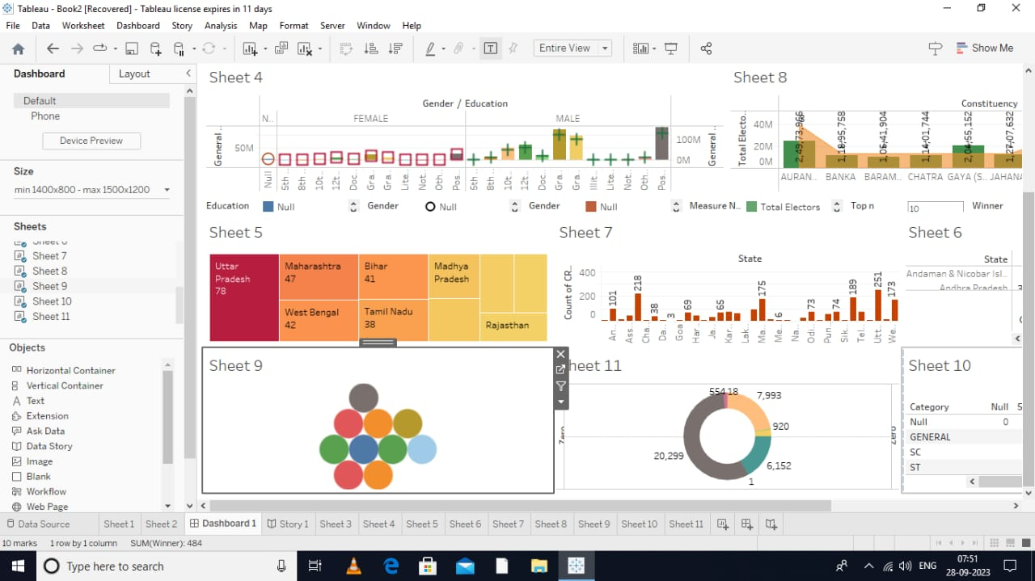

STORY

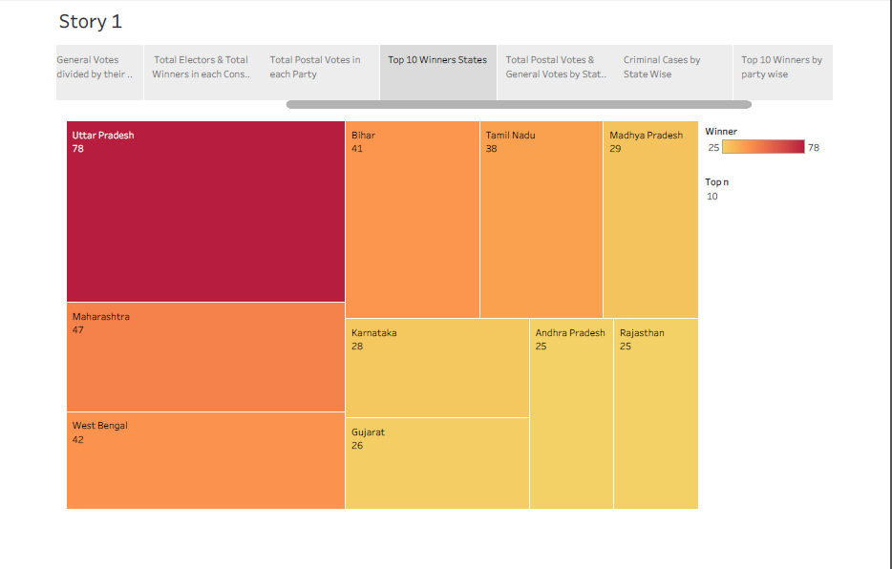

**Milestone:8 Publishing**

* Dashboard
* https://public.tableau.com/app/profile/boomika.m/viz/Dasboard_16961305738070/Dashboard1?publish=yes
* story
* https://public.tableau.com/app/profile/boomika.m/viz/Story1_16961314473070/Story1?publish=yes

**CONCLSION**

* In order to understand dynamics of trade liberalization, need to consider political economy of tariff choices
* Grossman and Helpman (1994) and others model tariffs in context of supply and demand for protection in political market
* Supply of protection is marginal cost to government of imposing tariff, cost being damage to economy
* Demand for protection linked to marginal benefits of tariff measured in terms of impact on profits of import-competing firms